https://akbuliderariyalur.blogspot.com/2023/10/ak-builders.html[AKbuilders](https://akbuliderariyalur.blogspot.com/?m=1)

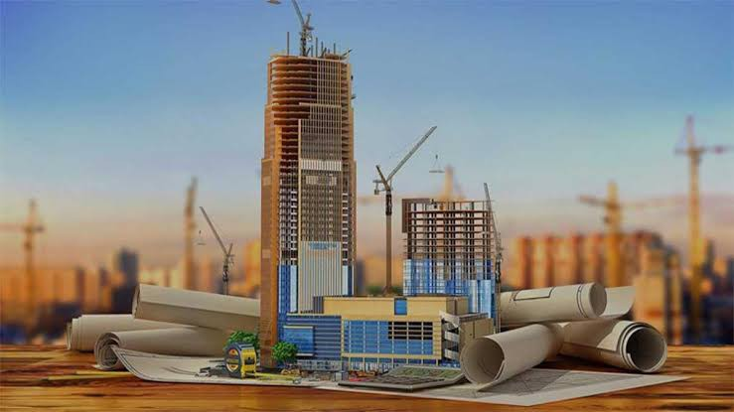

**AK builders**

[October 11, 2023](https://akbuliderariyalur.blogspot.com/2023/10/ak-builders.html?m=1)

Builders and construction play a pivotal role in shaping the world we live in. Builders, often comprising a diverse workforce of engineers, architects, laborers, and skilled craftsmen, are the driving force behind the creation of structures that deﬁne our cities and landscapes. From towering skyscrapers to intricate bridges and humble homes, builders are responsible for turning architectural visions into tangible reality.

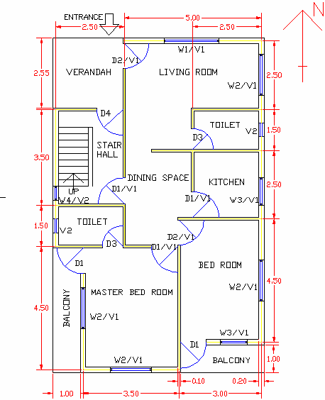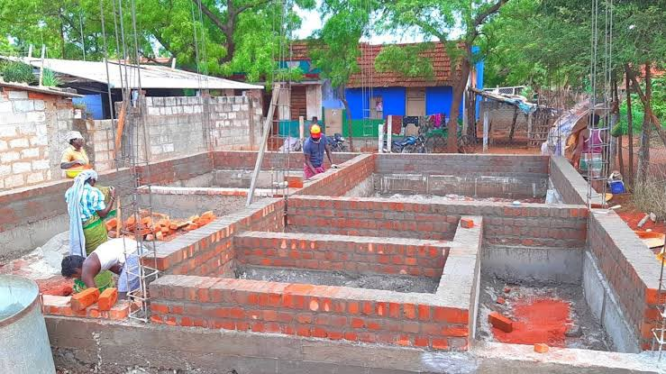

Construction, a multifaceted industry, involves the art and science of erecting structures that meet functional, safety, and aesthetic requirements. It requires meticulous planning, innovative techniques, and a keen focus on sustainability to ensure structures endure for generations.

The ﬁeld of construction not only fuels economic growth but also reﬂects human progress and ingenuity, leaving an indelible mark on the world's infrastructure and urban evolution.

House plans designed by engineers combine structural expertise with architectural creativity. These plans are meticulously crafted to ensure the safety and stability of the building while also reﬂecting the homeowner's aesthetic preferences.

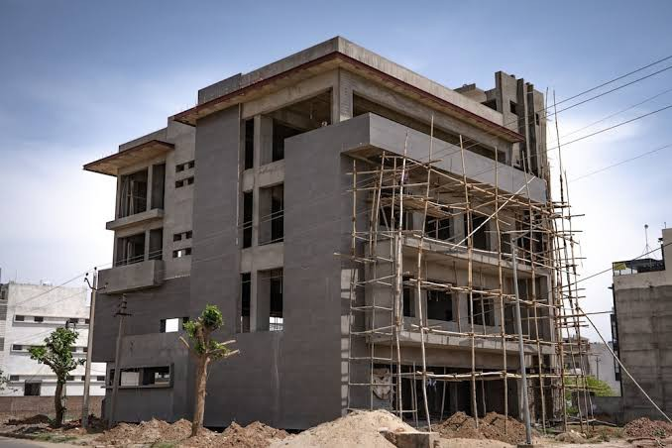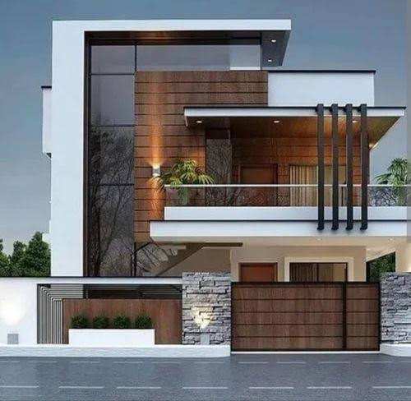

Engineers consider factors like load-bearing capacities, material selection, and earthquake resistance, seamlessly integrating them into the design. This results in homes that not only look stunning but also stand the test of time. Collaborating with architects, engineers bring precision to every aspect of the plan, from the foundation to the roof, creating living spaces that are both functional and aesthetically pleasing. The synergy of engineering and design in house plans guarantees the best of both worlds, where beauty and safety go hand in hand.

To our valued customers, we understand that embarking on a construction project is a signiﬁcant and often deeply personal endeavor. We are committed to making this journey a seamless and satisfying experience for you. Our dedicated team of professionals brings a wealth of expertise, ensuring that your vision is not only realized but surpassed. We prioritize your safety, comfort, and satisfaction at every step. From adhering to the highest quality standards and budget constraints to meeting project timelines, our focus remains steadfast

on your needs. We are here to communicate openly, address your concerns, and deliver a ﬁnal product that not only meets but exceeds your expectations. Your dream home or project is our passion, and we are honored to be a part of this transformative process with you. Thank you for entrusting us with your construction needs.

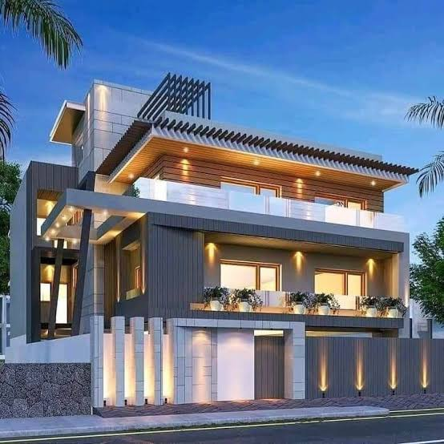

[#constructions#Dreamhome#buildinghouses #house#builders](https://akbuliderariyalur.blogspot.com/search/label/%23constructions%23Dreamhome%23buildinghouses %23house%23builders?m=1)

[Powered by Blogger](https://www.blogger.com/) [Report Abuse](https://www.blogger.com/go/report-abuse)